The secret to becoming good in SOLIDWORKS is it to practice using the software. Here is an exercise to polish the skills you gained in this section.

Download the model from the download section. Do (and answer) the following.

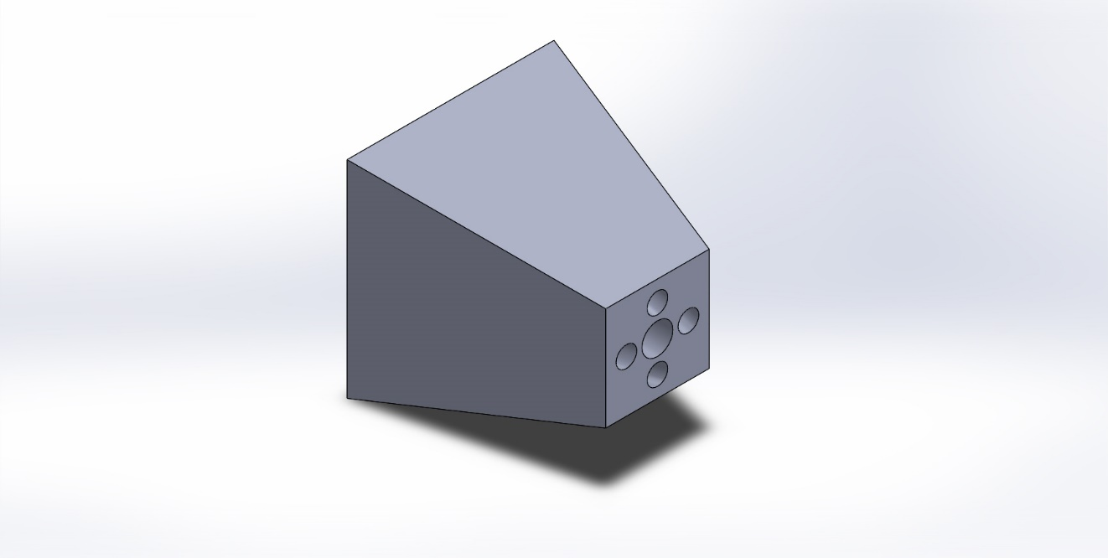

1- Change the model's material to Plain Carbon Steel. Find the following

* a. Mass of of the model in grams:
* b. Mass of the model in pounds:
* c. Center of mass of the model in inches:
* d. What is the volume in cubic mm:
* e. What is the surface area in inches square:
* f. What is the density of Plain Carbon Steel in grams/cubic mm:

2- Adjust the indicated side from 50 mm to 80 mm. Also, change the material to Silicon Rubber. The find the following:

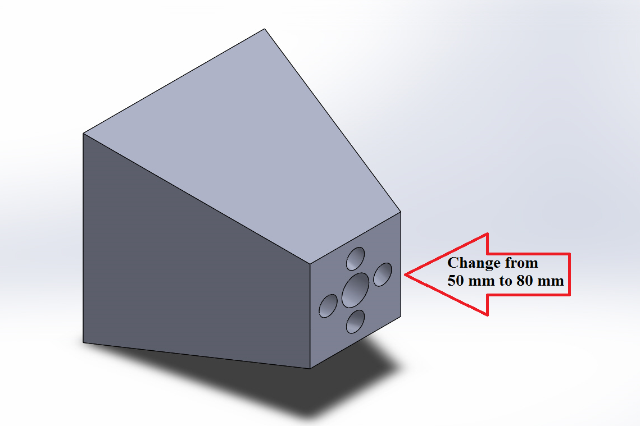

* a. Mass of of the model in pounds:
* b. Mass of the model in kilograms:
* c. Center of mass on the model in inches:
* d. What is the volume in cubic inches:
* e. What is the surface area in mm square:
* f. What is the density of Silicon Rubber in pounds per cubic inch:

3- Is the center of mass the same for the model in steps 1 and 2 above? (YES/NO)

------ END OF EXERCISE ------

---- Answer Key -----

**1-**

* a- 4167.13 grams
* b- 9.19 pounds
* c- X = -2.43, Y = 00, Z = 00 inches
* d- 534247.05 cubic millimeters
* e- 92.87 square inches
* f - 0.01 gram per cubic millimeter

**2-**

* a- 2.10 pounds
* b- 0.95 kilograms
* c- X = -2.12 , Y = 00 , Z = 00 inches
* d- 46.64 cubic inches
* e- 68907.49 square millimeters
* f- 0.05 pounds per cubic inch

**3-**NO